Visites de Recherche
Research Visits

2017 Call

Ulysses

Application Form

Pour tous les chercheurs des universités et instituts

For all researchers in third level colleges

or in publicly funded research institutions

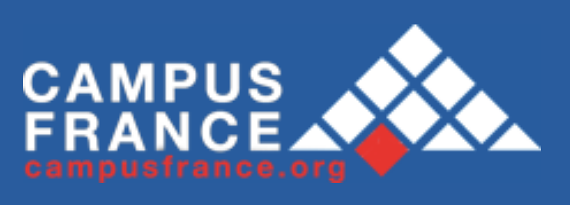
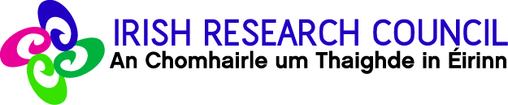


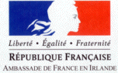

Application for Research Visit to France

Section A - 1/3
Proposals must be submitted by academic or research staff
who are authorised by their institution to be responsible for grants.

PARTNERS

 | IRELAND | FRANCE
Project leader
(Last name, first name)
Current position

Period held

Institution

Department

Name of Director/
Head of Department
Address

Telephone
Fax
E-mail
Other participant (s)
in the project (name, position)

PROJECT SUMMARY

Title (max. 100 words)

Abstract (max. 200 words)

Section A - 2/3

Resources required

Resources required | Researcher based in Ireland going to France  € | Researcher based in France going to Ireland  €
Name and title of researcher 1
Destination
Duration
Travel cost
Subsistence cost
Name and title of researcher 2
Destination
Duration
Travel cost
Subsistence cost
Name and title of researcher 3
Destination
Duration
Travel cost
Subsistence cost
Total Request
(Max award of €2,500 per side)

Details of additional group members should be filled out on a separate page.

Please state the nature of any research grant currently held by the project leader from Ireland - detailing the funding agency, duration of grant, institution which processes grant payments.

Have any members of the proposed collaboration received funding in the past 5 years from one or more of the sponsoring organisations (IRC, IRCSET, IRCHSS, HRB, French Embassy, Campus France, Égide)? – If yes, please specify year(s), awards etc.:

Have any applicants in the proposed collaboration received Ulysses funding in the past 5 years? If yes, please give details of project leader and year; a synopsis of previous funding under Ulysses should also be attached to this form (max 1 page). The synopsis should briefly outline the funded research project, any successful outputs/outcomes and any follow-up activities (continuation or expansion of the collaboration).

European dimensions: (Detail any existing participation in EU programmes, including name of programme and partners).

Other international dimensions: (Detail any existing international collaboration)

Project themes (Please tick the one that best describes the research discipline.)

mathematics
physics and engineering
earth sciences, astronomy
chemistry
life sciences

space, aeronautics

biotechnology

food

pharmaceuticals, medical devices

computer science, telecommunications

energy, environment, transport, natural resources

agrifood research and rural environment

humanities including languages

Social Science and Economics

Law

Business

Other: (specify)
Section A – 3/3

Projected Outcomes

Training and career development of early-stage researchers: (Will this project afford training and career development opportunities for early stage researchers (i.e. postgraduate students and postdoctoral fellows)?)
YES/NO (please delete as appropriate)
If yes, please provide a brief summary:

Training through research: (Will this project involve training through research, in particular, co-supervision of a thesis? If so, please give the names of those doctoral students, together with their research subject.)
YES/NO (please delete as appropriate)
If yes, please provide a brief summary:

Expected project outcomes: (Journal articles, conference and seminar papers, seminars, training, economic, social, industrial viability, patents, proposals under Horizon 2020)

Industrial dimensions current or expected where appropriate : (Detail any industrial partners where relevant and beneficial outcomes expected)
YES/NO (please delete as appropriate)
If yes, please provide a brief summary:

Intellectual Property
The attention of researchers is drawn to the need to take steps to protect intellectual property and the possibility of transfer of technology to another country.

APPLICANT’S DECLARATION

I declare that the above particulars are correct and I understand that terms and conditions apply. I accept that failure to abide by the terms and conditions may disqualify me from this scheme. I also authorise the Irish Research Council to verify, if necessary, any of the information supplied in this application.

Signature of project leader

Date

ENDORSEMENT BY INSTITUTIONAL AUTHORITIES

I hereby endorse this application in accordance with the terms and conditions.

Signature of Head of Department/
Head of School/Faculty or equivalent
(please indicate position held)

Date

Signature of Vice-President for Research or equivalent authorised signatory
(please indicate position held)

Date

Institution stamp:

Checklist:

1. Application form completed with Irish and French partner details

2. Description of project attached (2 pages maximum, excluding references):

N.B. The project description must be intelligible to academics in neighbouring research fields.
- Research aims and objectives
- Proposed methodology
- Research plan, including a schedule for task completion
- Reason for collaboration (e.g. shared knowledge, skills, equipment)
- Contribution to training and career development of early-stage researchers (i.e. postgraduate students and post-doctoral researchers)
- Recent significant publications relating to the research project (5 maximum)

3. Curriculum Vitae

Please attach a one page (maximum) CV for each of the team members (in both Ireland and France).

4. Previous Ulysses funding

Please attach details (1 page max) of Ulysses funding obtained with in the past 5 years, including project aims, partners, successful outcomes and any follow-up activities (continuation or expansion of collaboration).

5. Spread-sheet containing application details

Please complete one electronic copy of the spreadsheet ‘UlyssesProjectDetails_your_name.xls’ file.

This is available for download at: http://research.ie/assets/uploads/2017/05/Ulysses-Project-Details-2017.xls.

Submission Process (two-stages):

NB: An application form submitted by the Irish research partner(s) to the Irish Research Council must be matched by an application form submitted by the French research partner(s) to Campus France, otherwise it will not be considered.

1. Electronic Submission:

Applicants are required to submit one electronic copy of this application form and all related attachments to ulysses@research.ie and copied to info@research.ie. The file should be in PDF format, and should include all parts of the proposal collated into one single file. Submission of multiple files is not permitted and will be disregarded. Applications not submitted in the PDF format will not be considered. Please submit one electronic copy of the spreadsheet file.

2. Hard-Copy Submission:

The completed applications form, including original signatures and institution stamp (no photocopies or scanned copies permitted) and all relevant attachments, should be posted to:

Ulysses Programme Officer
The Irish Research Council
Brooklawn House
Crampton Avenue
Shelbourne Road
Dublin 4

Do not submit a hard-copy of the ‘UlyssesProjectDetails_your_name.xls’ file.

Please note BOTH the electronic and hard copy submission must be received by the IRC by Midday on Friday 22 September 2017.

Applications received after this time will not be considered. Applicants are responsible for the timely delivery of BOTH applications. Appeals will not be considered.

