RESEARCH VISITS
VISITES DE RECHERCHE

2018 CALL

Ulysses

Application form

For all researchers in third level colleges
or in publicly funded research institutions

Pour tous les chercheurs des universités et instituts

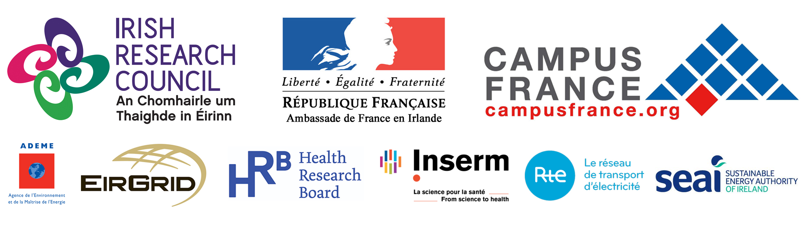

Section 1 – Disciplinary area

Please select a theme which best describes the disciplinary area of the application:

Mathematics
Physics and engineering
Earth sciences and astronomy
Chemistry
Life sciences
Space and aeronautics
Biotechnology
Food
Pharmaceuticals and medical devices
Computer science and telecommunications
Energy, environment, transport and natural resources
Agrifood research and rural environment
Humanities including languages
Social science and economics
Law
Business
Other (please specify)

Please indicate if the application is suitable for funding under any of the following strategic partnerships:

EirGrid in partnership with Réseau de Transport d'Électricité
Health Research Board in partnership with Inserm
Sustainable Energy Authority of Ireland in partnership with ADEME

Please note that applications submitted under these strategic partnerships will be made available to the relevant partner(s) for their consideration on a strictly confidential basis.
Section 2 – Partner details

 | IRELAND | FRANCE
Project leader

Current position

Period held

Institution

Department

Name of Director or Head of Department
Address

Telephone
Email
Other participant(s) in the project
(name, position)

This application form must be accompanied by a CV (one page maximum) for each of the team members (in both Ireland and France) referenced above.
Please detail any research award(s) currently held by the Irish-based project leader (including the funding agency, award type, duration of award, etc.):

Have any members of the proposed collaboration received funding from one or more of the strategic partners in the past five years? If yes, please detail the award type, duration of award, etc.:

Have any members of the proposed collaboration received Ulysses funding in the past five years? If yes, a synopsis of this previous funding should be included (one page maximum) which briefly outlines the current status of the collaboration, the outputs already obtained and those anticipated in the future:

Please detail the existing participation of any members of the proposed collaboration in EU programmes, including the name of the programme and associated partners:

Please detail existing international partnerships for any members of the proposed collaboration:

Section 3 – Project details

Title (maximum 100 words):

Abstract (maximum 200 words):

This application form must be accompanied by a description of the project written for a general scientific audience (two pages maximum).

Section 4 – Resources required

 | Irish-based researcher going to France | French-based researcher going to Ireland
Name and title of researcher 1
Position held
Department
Institution
Email address
Destination
Duration
Travel cost (€)
Subsistence cost (€)
Name and title of researcher 2
Position held
Department
Institution
Email address
Destination
Duration
Travel cost (€)
Subsistence cost (€)
Name and title of researcher 3
Position held
Department
Institution
Email address
Destination
Duration
Travel cost (€)
Subsistence cost (€)
Total request (maximum €2,500 per side)

Details of additional group members should be filled out on a separate page.

Section 5 – Projected outcomes

Will this project afford training and career development opportunities for early-stage researchers? If yes, please provide a brief summary:

Will this project involve training through research, in particular co-supervision of a thesis? If yes, please provide a brief summary in addition to the names of the relevant postgraduate student(s), together with their research subject(s):

Please detail the expected outcomes of the proposed collaboration, e.g. journal articles, conference and seminar papers, seminars, training, economic, social, industrial viability, patents, proposals under Horizon 2020:

Where appropriate, please detail any industrial partners and beneficial outcomes expected:

The attention of researchers is drawn to the need to take steps to protect intellectual property and the possibility of transfer of technology to another country.

Section 6 – Applicant declaration

I declare that the above particulars are correct and I understand that Terms and Conditions apply. I accept that failure to abide by the Terms and Conditions may disqualify me from this scheme. I also authorise the Council to verify, if necessary, any of the information supplied in this application:

Signature of project leader:

Date:

Section 7 – Endorsement by institutional authorities

I hereby endorse this application in accordance with the Terms and Conditions:

Signature of Head of Department/
Head of School/Faculty or equivalent
(please indicate position held):

Date:

Signature of Vice-President for Research or equivalent authorised signatory
(please indicate position held):

Date:

Institutional stamp:

Checklist

1. | Application form completed with Irish and French partner details | ☐
2. | CVs (one page maximum) for each of the team members (in both Ireland and France) referenced in the application | ☐
3. | A description of the project written for a general scientific audience (two pages maximum) | ☐
4. | Previous Ulysses funding details (where relevant) | ☐

SUBMISSION PROCESS

- One electronic copy of the application form and all related attachments must be submitted to the Council via email to ulysses@research.ie by a person authorised by their institution to hold responsibility for research grants. This copy must include original signatures and institutional stamp.
- The file should be in PDF format and should include all parts of the proposal collated into one single file. Submission of multiple files is not permissible. Applications not submitted in PDF format will not be considered.

Please note that applications must be received by the Council by 4pm (Irish time) on Wednesday, September 19, 2018. Applications received after this time will not be considered. Results will be announced in January 2019.

